Getting started with Allure Playwright

https://allurereport.org/docs/playwright/
- Install the Allure Playwright adapter and make sure that the Playwright framework itself is also listed in the project's dependencies.
- npm install --save-dev @playwright/test allure-playwright
- In the playwright.config.ts file, add Allure Playwright as a reporter.
export default defineConfig({
// ...
reporter: [["line"], ["allure-playwright"]],
});
- npm install --save-dev @playwright/test allure-commandline
- Run your Playwright tests the same way as you would run them usually. For example:
- npx playwright test

Generate a report
Finally, run Allure to convert the test results into an HTML report. This will automatically open your browser to view the report.
npx allure serve allure-results

- To Skip any test in command : @Smoke tags test get ingnore
npx playwright test –grep-invert ‘@Smoke’

- We can customise command in package.json file under Script section
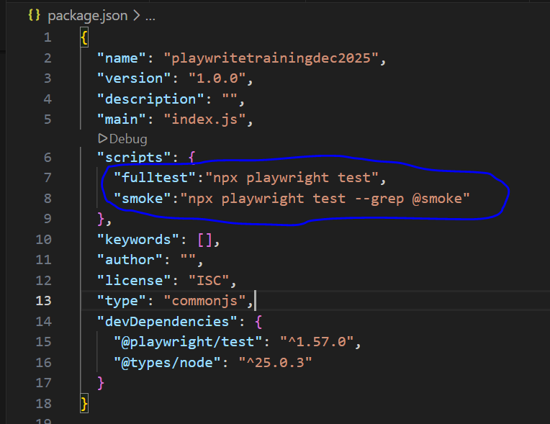
To run just type in terminal
Command: npm run smoke, npm run fulltest

